Item body here

Confidentiality Agreement
The undersigned reader acknowledges that the information provided by _______________ in this business plan is confidential; therefore, reader agrees not to disclose it without the express written permission of _______________.
It is acknowledged by reader that information to be furnished in this business plan is in all respects confidential in nature, other than information which is in the public domain through other means and that any disclosure or use of same by reader, may cause serious harm or damage to _______________.
Upon request, this document is to be immediately returned to _______________.
___________________
Signature
___________________
Name (typed or printed)
___________________
Date
This is a business plan. It does not imply an offering of securities.

1. Executive Summary 1
1.1. Objectives 1
1.2. Mission 2
1.3. Keys to Success 2
2. Company Summary 3
2.1. Company Ownership 3
2.2. Start-up Summary 3
3. Products and Services 5
4. Market Analysis Summary 7
4.1. Market Segmentation 7
4.2. Target Market Segment Strategy 8
4.3. Service Business Analysis 9
4.3.1. Competition and Buying Patterns 10
5. Strategy and Implementation Summary 1
5.1. Competitive Edge 1
5.2. Marketing Strategy 1
5.3. Sales Strategy 2
5.3.1. Sales Forecast 2
5.4. Milestones 5
6. Web Plan Summary 6
6.1. Website Marketing Strategy 7
6.2. Development Requirements 7
7. Management Summary 7
7.1. Personnel Plan 7
8. Financial Plan 12
8.1. Important Assumptions 12
8.2. Break-even Analysis 12
8.3. Projected Profit and Loss 13
8.4. Projected Cash Flow 16
8.5. Projected Balance Sheet 18
8.6. Business Ratios 19

Executive Summary
To be supplied after we agree to more details

Highlights
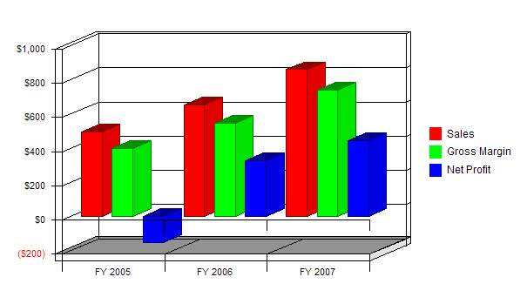

Objectives
MedCommons objective is to provide secure access to selected diagnostic studies anywhere in the US. MedCommons provides access to studies through a Web browser and a Web Service based platform for Application Providers to build higher order analysis, diagnostic, and other services.
MedCommons introduces structure and methods to enable large-scale patient-specific information analysis (often called Computer Assisted Diagnosis - CAD) across the network, achieving FDA compliance through the use of open source software methods. We will provide a ubiquitous HIPAA compliant platform for universal global access to DICOM and HL7 diagnostic studies. Our intention is to build a transaction fee based service for the safe transport of and access to studies.

Mission
MedCommons mission is to provide a HIPAA compliant universal platform for global access to diagnostic studies based on open source software, allowing any DICOM or HL7 diagnostic studies to be accessed securely in real-time. Our goal is to foster the development of multiple higher order services (second opinion services, diagnosis, clinical trials) based upon the MedCommons platform.
The MedCommons approach innovate in the use of peer-reviewed, FDA-regulated Open Source software and a unique collaboration between patient communities, a new class of Internet service laboratories and physicians... MedCommons focuses on diagnostic technology and the analyses that contribute to a diagnosis because improved diagnostic information provides powerful leverage to reduce both risk and unnecessary therapy at the same time. Through this collaborative network, MedCommons helps to realign the relationship between patient and physician while reducing physicians' risk.
MedCommons has developed a new, patentable method that simultaneously enables both patient control and rapid technological advances in diagnostic analyses without compromising safety, quality of service or the valuable role of the physician as advisor. Health care costs will be reduced directly through reduced technology costs and, more important, indirectly through a reduction of unnecessary care. All patients will benefit from more open, scientifically peer-reviewed and less conflicted diagnostic technology. In addition, those patients who wish to make use of every option available for their own healthcare decisions will be able to control their interaction with physicians, pharmaceutical and medical device companies to a greater extent than ever before.
The MedCommons method makes it possible for MedCommons Laboratories (MCL) to avoid substantially all of the risk of providing sophisticated computerized analysis of advanced patient-specific information (e.g.: CT, MR, Genetic scans). The MedCommons method establishes the relationships between MCL, hospitals, imaging centers, diagnostic service providers, medical device manufacturers , patients, and physicians in a sustainable manner that fits within existing FDA medical device regulations.

Keys to Success
The keys to our success are:
- Development and Deployment of MedCommons Appliances at a critical mass of hospitals and imaging centers
- Securing key relationships with Pharmas and CROs for supplying studies to clinical trials
- Building Instant 2nd opinion capability for Insurers
- Encouraging established device manufacturers to embed MedCommons appliance kernel in next generation of new devices
- Ensuring FDA and HIPAA compliance from day one
- Keeping the business as lean as possible
  - Encouraging cross industry participation in the development of diagnostic study viewers
  - Partnering with hardware vendor on deployment of appliances

Company Summary
MedCommons is incorporated as a limited liability company in the state of Delaware and is headquartered on the Internet. The Company founders and shareholders include Adrian Gropper, Sean Doyle, Edie Pargh, and Bill Donner.

Company Ownership
MedCommons is a privately-held C corporation owned in majority by its founders Adrian Gropper, Hugh Sean Doyle, Bill Donner and Edie Pargh, all of whom serve on the board of directors. As part of our capital raising activities we expect to add several additional investors and shareholders

Start-up Summary
Our start-up costs will be $2M, which includes $400K for the hardware provisioning and licensing of 5 appliances, and a single site, fully redundant MedCommons Portal system
The remainder of the funds will be used for:
- Consultants: $500,000
- Initial Capitalization: $225,000
- Legal, Insurance, Rent & Misc: $125,000
- Completition of Research and Development $650,000
The start-up funding will be financed by an investment round to be initiated in March, 2004.

Start-up
Requirements
Start-up Expenses
Legal | $40,000
Stationery etc. | $1,000
Brochures | $0
Consultants | $50,000
Insurance | $15,000
Rent | $5,000
Research and Development | $400,000
Expensed Equipment | $225,000
Other | $0
Total Start-up Expenses | $736,000
Start-up Assets Needed
Cash Balance on Starting Date | ($736,000)
Other Current Assets | $0
Total Current Assets | ($736,000)
Long-term Assets | $0
Total Assets | ($736,000)
Total Requirements | $0
Funding
Investment
Investor 1 | $0
Investor 2 | $0
Other | $0
Total Investment | $0
Current Liabilities
Accounts Payable | $0
Current Borrowing | $0
Other Current Liabilities | $0
Current Liabilities | $0
Long-term Liabilities | $0
Total Liabilities | $0
Loss at Start-up | ($736,000)
Total Capital | ($736,000)
Total Capital and Liabilities | ($736,000)

Start-up
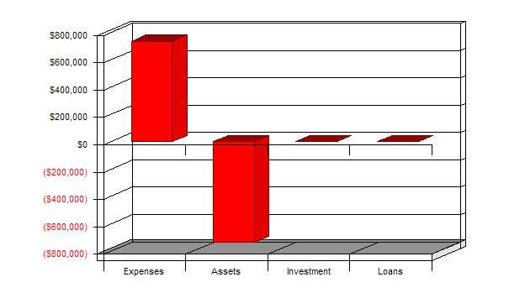

Products and Services
MedCommons provides secure access to selected diagnostic studies anywhere in the US.
MedCommons, Inc intends to launch a US based MedCommons Portal as an FDA and HIPPA compliant ASP. We will charge fees based on transaction volumes (separately detailed), with premiums for dedicated bandwidth. The Image Tracking and Storage services will be supplied in source form, as a sample 3rd party service which MedCommons will also be offered as part of the basic ASP service.
MedCommons provides a HIPAA-compliant access service for all DICOM and HL7 diagnostic studies nationwide. Through a Web browser, studies are tracked, identified and accessed either by a unique tracking number or by the location where they originated and the patient's identity. Study status might include Ordered, Performed and Final. Study access might display an image or report in a Web browser or in a DICOM viewer.
MedCommons is a pure tracking and transport service - a la FedEx. On-line access to a study is typically available for less than a month. Long-term storage and institutional workflow are outside the scope of the core MedCommons service and may be provided by PACS.
The MedCommons Network is an overlay over the Internet, that facilitates the creation of advanced Medical Imaging Services by providing secure, peer to peer transmission of medical images between different scanners, devices, hospital lans, workstations, and internet browsers as used by radiologists, lab technicians, physicians, and patients. There are several major components that we will be delivering as the first release of MedCommons.
The DICOM OSS Appliance Kernel is comprised of existing off the shelf open source software written by various industry contributors and additional software supplied by MedCommons. The appliance kernel can be loaded and run on commodity hardware, or fashioned into an appliance, or embedded into a PACS or scanner. The primary functions of the appliance kernel are to handle local image storage and transfers to and from other appliances.
A managed Medcommons Appliance, built on the DICOM OSS appliance kernel will be deployed on every participating modality LAN as a gateway between the hospital LAN and the MedCommons Network. The appliance interfaces with the CT scanners and MRI devices via the local Ethernet, and selecting images that are of interest to the network, storing them locally and eventually participating in the transfer and storage of these in other appliances at other institutions. The appliance adds both remote and local user administrative interfaces as well as additional security features to the basic open source package
Alternatively, the devices themselves will directly embed the DICOM OSS Appliance Kernel. The MedCommons Certification Service consists of processes and tests to ensure that the device will function correctly on the network and interoperate with every other managed device.
One or more MedCommons Portals monitor and control the appliances, coordinating synchronized appliance to appliance secure image transfers across institutional firewalls according to schedules or on demand. Thus, the appliances function as local buffers within a hospital, and will typically have storage for a week's worth of images. A portal, responding to Web Service requests from an Application Service, checks entitlements and rights and then gets the two appliances to transfer a particular set of images. The User Interface for the MedCommons Portal is re-brandable and easily localized and internationalized. We anticipate some sovereignties will want to run their own Portal, as will some channel partners, and in some markets, Portals might compete for the business of Application Service providers.
MedCommons will construct some basic application services and we expect a vigorous market with many 3rd parties delivering additional services based upon the portals. The long term Image Storage Service will be released by MedCommons as a means of offloading storage from the managed appliances. The Image Tracking Service allows a patient, physician, or lab technician to determine the status and location of a set of image scans whether in an appliance, in a long term storage repository, or as yet to be scheduled. We anticipate third parties constructing Analysis, Modeling, and Referral services on top of the MedCommons Portals.
DICOM Studio permits the viewing of images and manipulation of image metadata on any appliance or Storage Server on the MedCommon Network. We will assemble the DICOM Studio based on the open source Dicom Viewers and the Eclipse Modelling Framework. By utilizing Eclipse, DICOM Studio will allow for the eventual migration of advanced workstation functionality into an open source environment.
We anticipate the DICOM OSS Appliance Kernel and DICOM Studio to be licensed under the GPL or BSD open source licensing schemes. By making these components open source we are hoping to build an industry-wide collaborative development team in the same manner as Linux. Both components offer a plug-in architecture to allow proprietary security and visualization extensions to be added to the open source codebase.
The MedCommons Portal, on the other hand, is built upon proprietary code and represents fundamental unique intellectual property of MedCommons, Inc. It contains no GPL or other open source code that would force us to redistribute the portal software. Since the value of a network increases super - linearly with the size of the community, it is important to have as few portals as possible, subject to the rules and regulations of multiple governments. It should be possible to utilize the appliances without the MedCommons Portal, but we believe the most benefit will be derived from simply hooking the MedCommons Appliances and embedded devices directly to the appropriate portal.

Market Analysis Summary
The market for diagnostic studies includes radiology images and laboratory tests. The numbers below are a first cut at quantifying the imaging side. The lab test market includes blood tests, pathology images and the emerging genomics and proteomics scans.
Each of some 10,000 sites that produce over 100 million high-resolution (CT, MR, Mammography) digital scans in the US is a candidate to install an MC Proxy. Over 200,000 surgeons, radiologists, other specialists and most primary care physicians have the potential to access the MC Portal directly over the Web or indirectly through their PACS or electronic medical record workstations. [note: these numbers are very rough]
A small but rapidly growing fraction of these 100 million scans is already being processed by image analysis services within academic medical centers such as the MGH 3D Lab and by national service providers such as Medical Media Systems. Additional reimbursement for these image analysis services ranges from nothing to over $500 per study.
There is insufficient data to estimate the market value of managing transport security and logistics for these 100 million scans to the respective analysis, interpretation and archiving services but a $1-10 range is probable with the low end being for archival storage and the high end being for image analysis or image management services delivered direct to the patient.
As a neutral, national transport logistics provider, MedCommons will participate in a direct market potential of $ 0.1 to 1 Billion.

Market Segmentation
Our market segmentation is straightforward, and we will be attacking three separate areas:
- CROs who are running clinical trials for drug companies and must acquire, organize, and track the diagnostic studies of tens of thousands of patients over time
- Hospitals and imagining centers who compete for business and need to have best of breed services available so that they are sent patients by referring physicians
- Remote diagnostic services, whether by man or machine, which examine diagnostic studies for the purpose of primary or second opinions

Market Analysis
Potential Customers | Growth | 2004 | 2005 | 2006 | 2007 | 2008 | CAGR
CROs | 25% | 100,000 | 125,000 | 156,250 | 195,313 | 244,141 | 25.00%
Remote Teleradiology | 20% | 750,000 | 900,000 | 1,080,000 | 1,296,000 | 1,555,200 | 20.00%
2nd Opinion Services | 30% | 750,000 | 975,000 | 1,267,500 | 1,647,750 | 2,142,075 | 30.00%
Total | 25.28% | 1,600,000 | 2,000,000 | 2,503,750 | 3,139,063 | 3,941,416 | 25.28%

Market Analysis (Pie)
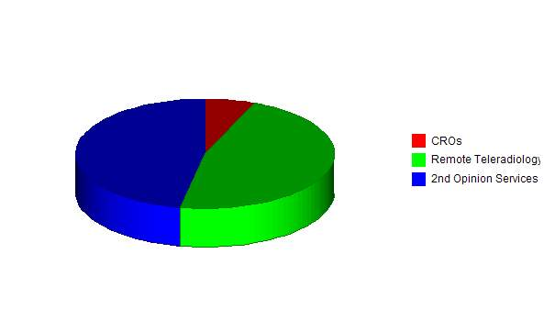

Target Market Segment Strategy
MedCommons has chose these markets because that's where the money is. There is little chance of collecting significant direct usage fees from patients or physicians, so we have chosen to make the service free for them. However, the pharmas, the hospitals, and the imaging centers all have the need to streamline the process of handling, transporting, and safely storing diagnostic studies over time, and have the funds to pay for the MedCommons service.
The MedCommons service will be valuable to large hospitals that are in the business of selling imaging data. It will get the data out to their customers faster and more reliably, at a lower cost to the hospital.
All Imaging Centers will need to be on the MedCommons service over time. As more physicians realize that they will have easier access to patient's images that available over the MedCommons Network, they will naturally route their patients to appropriately configured centers.
The Pharmas and CROs, realizing that they can more readily track patients over time and with absolute security and reliability at a lower cost will prefer the MedCommons network to current custom film based practices. The fact that we will shave months off of the current process will be a great driver for adoption of the MedCommons network.

Service Business Analysis
We are pioneering a new industry. MedCommons will enable all participants in the healthcare industry to benefit from reliable, secure, and timely access to diagnostic information. We outline some of the drivers for patient control of their own healthcare information, and how this will increase takeup of MedCommons.
The value of information in reducing risk is universal. In healthcare, the management and monetization of risk takes many forms and is mediated by FDA regulations, branding and a variety of costly patient-to-physician and physician-to-physician relationships. When risk management breaks down malpractice suits (both appropriate and frivolous) increase, as does wasteful defensive medicine that does not serve the needs of the patient and is a drag on innovation.
Information growth is also universal. At 80%, Health information lags only email (93%) and product research (83%) as a reason for going online. Growth in online information is shifting the role of patient and doctor. Examples of this shift include patients paying for out-of-pocket "body scans" to collect information and to manipulate the gatekeeper function of managed care physicians. Another example is the growing frustration of physicians at uncompensated requests to review and discuss information collected by patients via the Internet.
Our working assumption is that since good information reduces risk and cost, restrictions on information access are not a viable long-term strategy for patients and they will always find ways to circumvent such restrictions despite the efforts of regulators and providers.
MedCommons is designed to feed the patient's appetite for healthcare information specific to them and their situation with peer-reviewed and fully FDA regulated information. Until recently, specificity and personalization have been the exclusive domain of physicians and "the practice of medicine". The Internet will not remove this exclusivity. What the Internet can do is to help change the role of the physician from controller to advisor.
From the patient's point of view, the controller is responsible for both the information and the advice resulting from its analysis. An advisor, on the other hand, does not control what information is collected and analyzed but plays a lead role in sorting through conflicting analyses in light of information that the analyses may not have adequately considered. The advisor can also aid in rejecting completely inappropriate or low quality analyses. In any case, a physician role shift from controller to advisor transfers some risk from the physician to the patient.
MedCommons believes that increased access to patient-specific information will improve healthcare by accelerating innovation, facilitating safety and effectiveness regulation, and reducing unnecessary care. This "supplier induced demand" for care is increasingly mediated by direct-to-patient advertising and/or a regional surplus of health care facilities.
MedCommons Affiliates, in the form of disease-oriented Internet communities and the software developers that they attract, will develop much of the software that is used for analysis of patient-specific medical information. Many Affiliates will evolve from today's charity-supported organizations and will employ, scientifically preferred open source software community development methods to increase innovation of sophisticated analysis.
The founders of MedCommons believe that increased access to open, objective, peer-reviewed medical diagnostics in a structure that facilitates patient control will improve outcomes and reduce health care costs. The principal mechanism for these improvements is a reduction in the amount of inappropriate and unnecessary therapy that some studies claim wastes up to 30% of total health care expenditures.

Competition and Buying Patterns
Vendors of advanced image interpretation workstations based on the traditional model of workstations on a LAN. This approach requires expensive ongoing training for imaging facility technicians as they struggle to keep up with accelerating software upgrades. Inadequate workflow standards have made PACS integration a purely proprietary affair. Only one of these vendors is typically installed by any given imaging center, therefore, any physician requesting another vendor's test is basically out of luck.
- GE 3D Display (probably market leader)
- Siemens 3D Display
- Vital Images 3D Display; Calcium Scoring; Virtual Colonoscopy (public co.)
- Voxar 3D Display; Calcium Scoring; Virtual Colonoscopy (AMICAS partner)
- R2 Technologies Mammography and some Chest CT (CAD market leader)
- CADx Mammography CAD
- iCAD Mammography CAD
Vendors of advanced image interpretation services using proprietary software and workstations (see-above) to provide nationwide access. MMS uses a proprietary DICOM VPN that is inaccessible to individual patients or physicians and not integrated with the workflow of any PACS.
- MMS AAA Modeling (private, sales <$10 million/year); 3D Display
- Wipro 3D Display, based in India, (MGH pilot stage)
Vendors of national image storage services. Like MMS, InSiteOne uses a proprietary DICOM VPN that is inaccessible to individual patients or physicians and not integrated with the workflow of any PACS.
- InSiteOne Secure DICOM Storage Services (small private co, PACS add-on)
- i3Archive Mammography Storage (new, unknown technology)
Suppliers of services for aggregation of patient information from multiple hospital LANs. Both efforts are early-stage and neither offers a patient control capability.
- Patient Safety Institute Sharing of medical records across hospitals (consortium?)
- Hx Technologies Sharing of medical records across hospitals (early startup)
Physician-directed access to patient information. The Center for Information Therapy - An odd consortium promoting "Information Prescriptions" that are typically patient education but could be extended to include diagnostic tests. Weak security and little concern with workflow or systems integration.
National teaching and academic research networks – Inadequate security and politically not inclined to commercial clinical application at this time. Some Open Source software.
- ACRIN American College of Radiology Network for Clinical Trials
- Medical Imaging Resource Center of RSNA for teaching and reference studies

Strategy and Implementation Summary
Emphasize putting out as many MedCommons Appliances as possible by developing various partner strategies via CROs, Insurers, etc, to fund the deployment of these boxes.
Contract with one or more service providers like MMS to utilize diagnostic studies
Contract with one or more CROs to provide images for clinical trials
More to come

Competitive Edge
MedCommons competitive advantage is derived from many factors. Although there are no direct competitors, the following features of MedCommons Network distinguish our service
- Always-on network of reliable appliances facilitates new 3rd party application services. Some of these services will be delivered by MedCommons as well.
- Reduced time for clinical trials with greater precision in patient tracking and followup. This has the potential for saving huge amounts of money, and will prevent costly errors requiring data interpolation.
- Storage service(s) supply neutral repositories for personal imaging, facilitating second opinion services. These repositories will be maintained by other service providers.
- Data Suppliers enjoy higher accuracy and lower cost delivery of anonymized diagnostic studies. This is much easier and lower cost that burning CDs. The
- Free access for Patients and Physicians. This drives demand for MedCommons appliance installation at hospitals and imaging centers
- Easy to use Web Services Platform for service providers. Makes it a snap to embed any of the MedCommons platform functions in a higher order service
- Embedded Billing and Branding services. Branding allows various channel partners the opportunity to rebrand MedCommons to serve the need of a particular market. Billing services allow 3rd parties and channel partners the opportunity to have MedCommons handle as part of unified monthly statement
- Open Source Appliance Kernel. Anyone can hook to the network by utilizing the basic code contributed by MedCommons. However, connection to the MedCommons Portal will require passing the appropriate certification suites.

Marketing Strategy
The marketing strategy is the core of our main strategy:
- Emphasize ubiquitous free access to diagnostic studies by patients, doctors, and insurance providers
- Inspire Hospitals, Imaging Centers to install MedCommons Appliances
- Inspire Medical Device and PACS Vendors to embed MedCommons Appliance Kernel
- Get Pharmas/CROs to sponsor deployment of MedCommons Appliances for lower cost clinical trials
- Get Insurers to sponsor deployment of MedCommons Appliances for lower cost 2nd opinions

Sales Strategy
We have a multiprong sales strategy::
We will sell directly to large data suppliers, like MGH, Columbia Pres/Cornell, Univ of Chicago, etc. These large hospitals will also facilitate appliance sales to organizations like MMS and similar who analyze images as a service
We will sell directly to large chains of imaging centers. Physicians will prefer to steer their patients to these centers if they permit direct access to images.
We will sell directly to CROs, who will in turn supply MedCommons Appliances to smaller
We will partner with Strategic Infrastructure players like IBM and HP who can
Sell equipment
Sell integration services inside hospitals, etc
Build storage Services
Have a real 'Grid' App' years ahead of schedule
We will preferentially select one Strategic Infrastructure partner and build the MedCommons Appliance on partner hardware/software platform.
We will inspire PACS and modality vendors to embed the DICOM Kernel directly into their devices.

Sales Forecast
We will specifically hire one individual to sell to large suppliers, like MGH, Columbia Pres/Cornell, Univ of Chicago, etc
We will specifically hire one individual to sell to larger chains of imaging centers
We will specifically hire one individual to sell to CROs
We will cover the appliance partner relationship and device manufacturers via CTO/CIO.

We will encourage contribution of Open Source code and will contribute all basic DICOM Appliance Kernel code and utilities to the non-profit.
We'll join all the committees and pump it up.

Sales Forecast
Sales | FY 2005 | FY 2006 | FY 2007
Data Suppliers | $24 | $28 | $32
CROs | $18 | $21 | $26
Appliance Vendor | $10 | $10 | $10
Device Vendor | $38 | $46 | $55
Imaging Centers | $403 | $544 | $734
Total Sales | $493 | $649 | $857
Direct Cost of Sales | FY 2005 | FY 2006 | FY 2007
Software Development | $45 | $48 | $52
Marketing | $15 | $16 | $18
Systems Integration | $36 | $41 | $47
Subtotal Direct Cost of Sales | $96 | $106 | $117

Sales Monthly
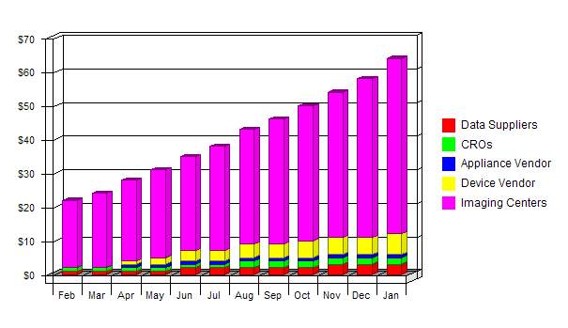

Sales by Year
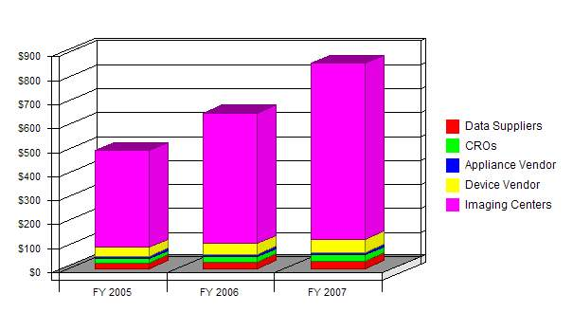

Milestones
The following table lists important program milestones, with dates and managers in charge, and budgets for each. The milestone schedule indicates our emphasis on planning for implementation. The general idea is to build the appliance, portal, and studio in parallel, and to release the appliance and portal a month in advance of the studio. Our goal is to have a CRO and an imaging center on board for the first release.

Milestones
Milestone | Start Date | End Date | Budget | Manager | Department
Dicom Oss Appliance Kernel | 2/1/2004 | 5/1/2004 | $100 | ABC | Engineering
MedCommons Appliance | 4/1/2004 | 7/1/2004 | $200 | ABC | Engineering
Dicom Studio | 3/1/2004 | 9/1/2004 | $50 | ABC | Engineering
MedCommons Portal | 2/1/2004 | 7/1/2004 | $250 | ABC | Engineering
MedCommons Storage Service | 5/1/2004 | 7/1/2004 | $50 | ABC | Engineering
MedCommons Call Center | 6/1/2004 | 9/1/2004 | $50 | ABC | Engineering
MedCommons General Release | 7/1/2004 | 9/1/2004 | $15 | ABC | Marketing
Dicom Studio Release | 9/1/2004 | 10/1/2004 | $15 | ABC | Marketing
First Remote Image Lab | 9/1/2004 | 9/15/2004 | $10 | ABC | Sales
First CRO Trial Initiated | 9/1/2004 | 12/1/2004 | $10 | ABC | Sales
Totals |  |  | $750

Milestones
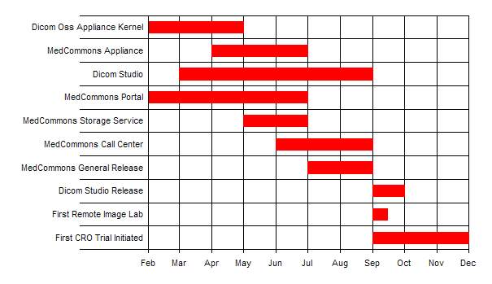

Web Plan Summary
The MedCommons website will be the virtual business card and portfolio for the company, as well as its online "home." The website needs to be a simple, yet elegant and well designed, as it is the primary access point for 'humans' into the MedCommons network. Physicians and patients will have a simple signon scheme which uses either biometric identification or password protected access with additional challenges as necessary to re-authenticate user identity.

Website Marketing Strategy
We will provide a variety of mechanisms to get casual browsers interested in participating in MedCommons:
- A high quality tutorial for patients and physicians on how to utilize the service
- ROI calculator for hospitals, imaging centers, hmos
- Sample web service examples for application service providers
- Testimonials, etc

Development Requirements
The MedCommons web site will be developed as part of the MedCommons service. The tutorials will be outsourced to a 3rd party developer that specializes in interactive, online training. We will have the web site up and running well before the launch of the service.

Management Summary
We have a finely tuned, expertly honed management team. More to come.

Personnel Plan
ADRIAN GROPPER, M.D.
Adrian has pioneered the use of computers and the Internet to deliver diagnostics to all physicians. For over 25 years, Adrian has used a combination of engineering and medicine to transition sophisticated diagnostics out of the specialist's lab and into everyday practice. Today, he's at the forefront of making diagnostics accessible directly to patients over the World Wide Web.
Adrian's career as a medical device developer began with undergraduate education in mechanical engineering and computer simulation at MIT, research on early diagnosis of lung disease at the Harvard School of Public Health, graduation from Harvard Medical School in 1978 followed by internship at the University of Oregon Health Sciences Center.
Beginning with a position as Director of Biomedical Research at Orion Research, Inc, Adrian pioneered the field of "physician's office" diagnostics with the first whole blood analyzer designed for use outside of a laboratory setting. The Orion 1020 introduced the use of embedded computers for fool-proof operation and quality control thereby enabling FDA clearance of a highly sophisticated device outside of a laboratory. Descendants of the 1020 design are still manufactured today by most of the suppliers in the blood electrolyte marketplace.
In 1983, Adrian established his entrepreneurial career as the co-founder of Analytix, Inc. The company developed the first robotic blood analyzer and had an IPO in 1986. In the early 1990's as the global threat of AIDS became clear, Adrian, working with the leading HIV diagnostic test supplier developed the first low cost, hand-held HIV tester for the developing world.
Adrian's work on imaging and affiliation with Massachusetts General Hospital began in 1991 with early work on the Center for Innovative Minimally Invasive Therapy a joint project of the MGH departments of radiology and surgery. Over the next few years, Adrian was responsible for the design and deployment of a number of pioneering telemedicine projects throughout the world and, as Chief Technology Officer of RSTAR, Inc, the genesis of the first generation of commercial diagnostic Picture Archiving and Communications Systems (PACS).
In 1995, Adrian Gropper and Sean Doyle founded AMICAS Inc, to bring diagnostic quality images to physicians outside of the radiology department PACS by using Internet technology. AMICAS' 1997 FDA-clearance of its flagship product preceded the next Web-based image management system by some 18 months. Today, AMICAS' Web-based PACS technology is installed in over 125 hospitals for use by both radiologists and other physicians. The list of hospitals includes such flagships as MGH, Boston Medical Center, New York Presbyterian and Cornell Medical Centers and The University of Chicago.
From the Orion 1020 to the AMICAS Web PACS, Adrian's career has consistently pursued the use of computer technology to demystify and remove subjective interpretation from the most broadly applicable diagnostics. Cooperation with and respect for the FDA mandates for advanced diagnostics have been a consistent element of all of his designs as he continues to "push the envelope" in advancing the scientific practice of medicine.
HUGH V. COTTINGHAM
Hugh has been an innovator for more than 25 years with an expertise analyzing research and medical diagnostic device needs and developing cost-effective business solutions. Consultant to the Fortune 500 medical device industry and licensor of numerous patents. Hugh initiated the development of various FDA regulated devices in clinical diagnostics, involving immunochemistry, DNA probe and amplification technology, and associated software.
Hugh's career as a medical device developer began with undergraduate education in biology and neurophysiology at Seton Hall University and research on the neurological basis of vision in animal models at UMDNJ.
Founding BHN, Inc., in 1974, a new-product development company, involved Hugh in development and licensing of one of the first low cost electronic fever thermometers for the consumer market. A further development, the first mass producible, plastic, lower limb prosthesis, became one of the first products to be accepted by the Veterans Administration for the ADL list, making it available to all veterans.
In 1982 Hugh licensed a clinical chemistry instrument for immunochemistry, which improved the sensitivity of the reagents by an order of magnitude. The success of this device led to further successful developments in immunochemistry and microfluidics which Hugh licensed, among others, to Roche, and which was marketed as the OnTrak™ drugs of abuse test, resulting in total sales of $100 million across 38 countries.
In the 1990's delivery of DNA amplification and probe technology to the market challenged all companies. Hugh met that challenge by developing and licensing complete systems including proprietary disposables, novel dried reagent delivery, and low cost real time instrumentation. These systems, licensed to Becton Dickinson, became the basis of ProbeTec™ DNA products.
Hugh was an early developer of Internet information management systems for inclusion in clinical instruments. Hugh developed web connected clinical instruments which published their results on automatically generated, searchable web pages, vastly reducing the time needed to communicate lab results throughout an institution.
As a parallel to medical device development Hugh has had more that 25 years in dealing with intellectual property through his patenting and licensing experience. Hugh knows the patent process intimately and has successfully prevailed over the patent examiner during interviews of the examiner at the USPTO. In 1998 the USPTO changed the law to allow "method" patents. In 1999 Hugh tested his ability and understanding of this new class of patents by filing an Internet business "method" patent, which was subsequently allowed.
Constant innovation, product development, and successful licensing have been the hallmark of Hugh's career.
SEAN DOYLE
Sean Doyle obtained a degree in Economics at MIT in 1983. Sean's main interest has been combining technology, ethnography, and public policy for greater social good. Although he initially thought that economic policy would be a good engine for social change he later concluded that building technical artifacts was the most efficient way for him to improve the world.
After graduation Sean developed econometric and statistical diagnostic algorithms at the MIT Center for Computational Research in Economics and Management Science and the Research and Statistics division of the Federal Reserve Board in Washington, DC. Sean also was a software consultant to the World Bank. Sean feels a deep debt to USENET for the communities that helped him learn different numeric and symbolic computer languages.
Sean's imaging career started in 1989 when he joined the RSTAR project at Massachusetts General Hospital's Department of Radiology. RSTAR later was spun out as an independent company and was the first commercial PACS vendor in 1992. RSTAR became an OEM supplier to 3M for their mini-PACS product. Sean worked on all parts of the system from custom hardware interfaces to workstation user interface design, including a structured measuring tool for an osteoporosis clinical drug trial which may have been the first completely digital imaging and measurement clinical trial cleared by the FDA. Sean became Director of Software engineering at RSTAR in 1992.
Sean left RSTAR to join the MIT Laboratory for Computer Science as a research programmer in 1994. Sean worked on a visual Bayesian calculator for computing probabilities of various genetic disorders. Sean also constructed the initial prototypes for a patient-centered life-long medical record. Sean's office was on the same floor as the W3 consortium - this is where he became infected with the World Wide Web and the protocols that comprise it. He has not yet recovered.
In 1995 Adrian Gropper and Sean Doyle founded AMICAS, Inc. to build a clinical imaging application built on web standards. Via judicious combination of protocols and formats AMICAS was able to deliver images using wavelets streaming over HTTP to the browsers on clinical desktops for fast, ubiquitous access. In 1997 an early web services interface was added so that other clinical applications could embed AMICAS viewers - several hospitals used this interface to insert patient images into their existing workflow and infrastructures. The AMICAS Web PACS has matured into a product in the top tier of the radiology market.
Sean's career has focused on making clinically centered software ubiquitously available through use of standards and commodity infrastructure.
Sean is a member of the IEEE, ACM, AAAS, and the SVP (Society of Vertebrate Paleontology).
BILL DONNER

After a reasonably undistinguished suburban New York childhood with some technical predilections Bill Donner attended the Massachusetts Institute of Technology, emerging in 1974 with a BSEE in Computer Science. Turning to industry as quickly as possible, he joined Digital Equipment Corporation, traveling internationally to set up and program large DecSystem-10 customer installations. In 1976 Bill got involved re-implementing a proprietary legacy compiler for the Teledyne Ryan Corporation, and ended up consulting and systems programming for a number of companies in San Diego area. Returning to the east coast, Bill ran a variety of financial services projects to interconnect the Chase Manhattan Bank to Swift, Chips, and Fedwire banking networks.
In the early 1980s, Bill built and ran Precision Business Systems; a Wall St. based Systems Integrator focused on financial telecommunications. PBS built and installed a variety of innovative systems including global communications switches and networks for Goldman Sachs, Bankers Trust, Chase Manhattan, Pacific and Bank of America, securities clearance systems for Bank of New York and Security Pacific, money transfer systems for Citibank, Manufacturers Hanover Trust, Irving Trust and others, a Japanese facsimile switching network for Nikko Securities, an airline check in network for VASP, the Brazilian state run airline, and the PriceWatch trading room systems for Chemical Bank in London, SGB in New York, and the floor system for the Montreal Stock Exchange. Many of these VAX based systems are still operational today.
Precision Business Systems was sold to the Bank of America in 1988. The PriceWatch product was sold to Digital Equipment Corporation in 1989. Bill spent the year as a consultant working with DEC to integrate PriceWatch into the DecTrade platform which DEC was actively marketing at the time. In 1990 Bill led the design and development of the Bank of America's MoneyMatch trading system, a Unix/TCPIP based system for anonymous trading of complex financial instruments. Because of the need to obtain a critical mass of customers, and the expense of a large network rollout the bank decided not to go forward with a rollout, and instead the MoneyMatch system was sold to Reuters in 1991.
Bill moved to Reuters along with the service and was put in charge of the Reuters Dealing 2001 and 2002 Trading Services. These proprietary networks services 30,000 online traders at 8,000 banks and brokerages in a 7*24*365 network. In today's parlance, Dealing 2001 is a peer based instant messaging service that utilizes real-time content analysis to build structured financial transactions for spot foreign exchange, while Dealing 2002 is a centralized anonymous automated matching service for currency exchange. Dealing 2003 incorporated the MoneyMatch functionality and added more complex instruments (forwards, IRAs, etc) and negotiated trading behaviors.
In 1994 Bill was named Chief Architect of Reuters with the goal of facilitating tighter integration of Reuters 39 separate development groups, and an online museum of computer and network history consisting of ten disparate networks, eight database services, 90,000 servers, and 500,000 users sitting at terminals. After two years of all too frequent trips to London, Bill and his family moved to the UK in 1995. Bill also ran the central research group, which focused on investigating and prototyping new technologies for automated content generation and analysis, video production and playback, object databases, rights management and security .
With the rapid commercialization of the Internet in 1995, the focus of Reuter's integration efforts shifted from the development of proprietary software on proprietary networks to open software on open networks. While retaining his architectural role, Bill joined the Greenhouse Group, Reuters' corporate venture capital arm, in 1996. With the mission of investing in technologies to enable migration to the Internet, the Greenhouse Group invested in a number of companies that were successfully integrated into either the company's infrastructure: Tibco, realtime messaging and inter-enterprise integration (IPO), Intertrust, digital rights management (IPO), Digimarc, content watermarking (IPO), Verisign, public key infrastructure security (IPO), or the company's new distribution exoskeleton: Yahoo (IPO), Infoseek (IPO) and Factiva (a Dow Jones-Reuters business information portal). Unlike most venture capitalists of the era, Bill had to actually try to utilize these new technologies for the benefit of Reuters which was always a bigger challenge than making successful investments in the 1996-1999 timeframe.
After returning to America in 1999, Bill joined Fenway Partners, a leading NY Private Equity Fund where he led the technology investment group. Fenway's technology investments include Tradeum, an exchange software provider (sold to VerticalNet), Supplier Market, a procurement network for custom built products (sold to Ariba), Wiscom, a 3G Wcdma wireless chip design house (IP sold to Intel), Odigo, a cellular instant messaging infrastructure provider (sold to Comverse), and iRobot, a military and consumer robotics company headed by Rodney Brooks, chairman of the MIT AI department. Privately, Bill was an angel investor in WebLogic, inventors of the Java application server (sold to BEA Systems), Amicas, a leading tele-radiology software provider, Kenamea, a secure messaging middleware platform provider, and Visible World, developers of personalized television commercial delivery and insertion systems.
Bill is currently serving as CIO of Elogex, Inc, a Dallas and Charlotte based Supply Chain Execution Management Service. After investing $30 million in Elogex and serving as Chairman, Bill moved into Charlotte in 2002 to facilitate scaling the J2EE/Oracle based shared ASP service to support the world's largest retailers. At the present time he is overseeing the development of a cooperative Elogex On Demand partnership with IBM for near real-time provisioning of storage, bandwidth and computational power, the rollout of an international franchisee network for servicing retailers in Europe, Latin America, and Asia, and squeezing the last bit of performance out of the software and database platform to improve operating margins.
Bill's entire career has been about building large systems that run continuously and eternally, at a reasonable price and affording a pleasant user experience. In his free time when he's not chasing after three teenage sons, cooking church breakfasts for the homeless, sweating on the recumbent bike, or getting left behind on the ski slopes; Bill plays keyboards in a Nixon-era rock and roll band and takes black and white digital photos. He's also an atrocious golfer.

Personnel Plan
 | FY 2005 | FY 2006 | FY 2007
Adrian Gropper | $120 | $0 | $0
Sean Doyle | $120 | $0 | $0
Bill Donner | $120 | $0 | $0
Hugh V. Cottingham | $120 | $0 | $0
Total People | 0 | 0 | 0
Total Payroll | $480 | $0 | $0

Financial Plan
To be supplied

MedCommons seeks $2 million to launch the organization and fund it for the first year. The initial scope of MCL is to provide patient-specific services over the Internet on a commercial basis and as such, MCL will require separate capital formation.

Important Assumptions
The key underlying assumptions of our financial plan shown in the following general assumption table are:
- We assume access to equity capital and financing to support our financial plan.
- We assume our financial progress based on realistic sales to minimum sales against highest expenses.
- We assume that our customers are willing to pay at least the amounts we have stipulated.

General Assumptions
 | FY 2005 | FY 2006 | FY 2007
Plan Month | 1 | 2 | 3
Current Interest Rate | 5.00% | 5.00% | 5.00%
Long-term Interest Rate | 7.00% | 7.00% | 7.00%
Tax Rate | 40.00% | 40.00% | 40.00%
Other | 0 | 0 | 0

Break-even Analysis
For our break-even analysis, we assume running costs of approximately $96,000 per month, which includes our full payroll, rent, and utilities, and an estimation of other running costs. Payroll alone, at our present run rate, is only about $55,000.
Margins are harder to assume. Our overall average of $5/1 is based on our assumption that we will receive an average of $5 per study transferred, and that our direct operational cost is $1 per transfer. We hope to attain a margin that high in the future. The good news, given Moore's law, is that we can see margins getting steadily better over time as bandwidth and storage become less expensive.
The chart shows that we need to sell about $335,000 per month to break even, according to these assumptions. This is about half of our planned 1996 sales level, and significantly below our last year's sales level, so we believe we can maintain it.

Break-even Analysis:
Monthly Units Break-even | 22,222
Monthly Revenue Break-even | $111,111
Assumptions:
Average Per-Unit Revenue | $5.00
Average Per-Unit Variable Cost | $0.50
Estimated Monthly Fixed Cost | $100,000

Break-even Analysis
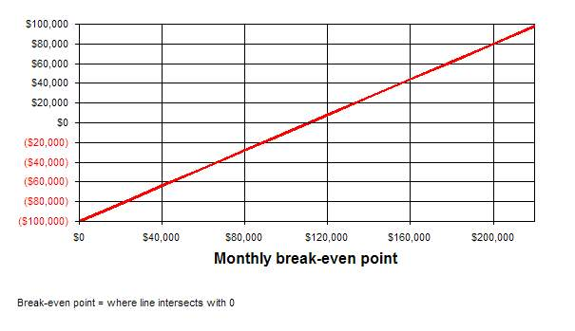

Projected Profit and Loss
To be supplied

Pro Forma Profit and Loss
 | FY 2005 | FY 2006 | FY 2007
Sales | $493 | $649 | $857
Direct Costs of Goods | $96 | $106 | $117
Other Costs of Goods | $0 | $0 | $0
 | ------------ | ------------ | ------------
Cost of Goods Sold | $96 | $106 | $117
Gross Margin | $397 | $543 | $739
Gross Margin % | 80.54% | 83.64% | 86.29%
Expenses:
Payroll | $480 | $0 | $0
Sales and Marketing and Other Expenses | $0 | $0 | $0
Depreciation | $0 | $0 | $0
Rent | $0 | $0 | $0
Utilities | $0 | $0 | $0
Insurance | $0 | $0 | $0
Payroll Taxes | $72 | $0 | $0
Other | $0 | $0 | $0
 | ------------ | ------------ | ------------
Total Operating Expenses | $552 | $0 | $0
Profit Before Interest and Taxes | ($155) | $543 | $739
Interest Expense | $0 | $0 | $0
Taxes Incurred | $0 | $217 | $296
Net Profit | ($155) | $326 | $443
Net Profit/Sales | -31.47% | 50.19% | 51.77%

Profit Monthly
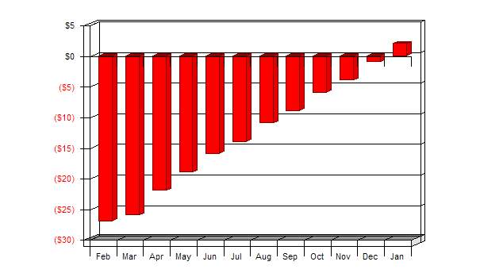

Profit Yearly
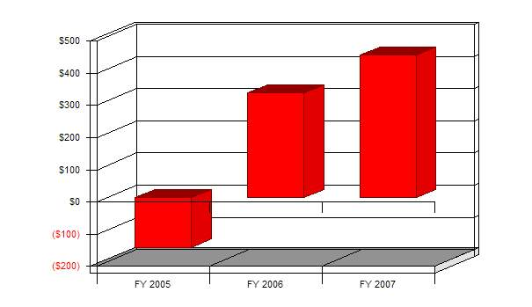

Gross Margin Monthly
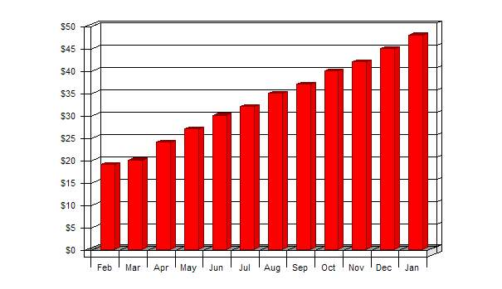

Gross Margin Yearly
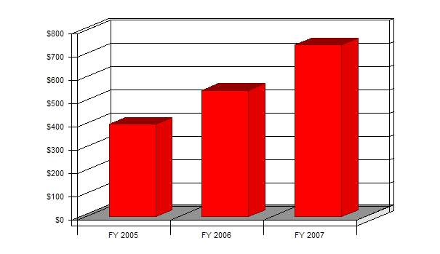

Projected Cash Flow
To be supplied

Pro Forma Cash Flow
 | FY 2005 | FY 2006 | FY 2007
Cash Received
Cash from Operations:
Cash Sales | $493 | $649 | $857
Cash from Receivables | $0 | $0 | $0
Subtotal Cash from Operations | $493 | $649 | $857
Additional Cash Received
Sales Tax, VAT, HST/GST Received | $0 | $0 | $0
New Current Borrowing | $0 | $0 | $0
New Other Liabilities (interest-free) | $0 | $0 | $0
New Long-term Liabilities | $0 | $0 | $0
Sales of Other Current Assets | $0 | $0 | $0
Sales of Long-term Assets | $0 | $0 | $0
New Investment Received | $0 | $0 | $0
Subtotal Cash Received | $493 | $649 | $857
Expenditures | FY 2005 | FY 2006 | FY 2007
Expenditures from Operations:
Cash Spending | $480 | $0 | $0
Payment of Accounts Payable | $146 | $316 | $404
Subtotal Spent on Operations | $626 | $316 | $404
Additional Cash Spent
Sales Tax, VAT, HST/GST Paid Out | $0 | $0 | $0
Principal Repayment of Current Borrowing | $0 | $0 | $0
Other Liabilities Principal Repayment | $0 | $0 | $0
Long-term Liabilities Principal Repayment | $0 | $0 | $0
Purchase Other Current Assets | $0 | $0 | $0
Purchase Long-term Assets | $0 | $0 | $0
Dividends | $0 | $0 | $0
Subtotal Cash Spent | $626 | $316 | $404
Net Cash Flow | ($133) | $333 | $453
Cash Balance | ($736,133) | ($735,800) | ($735,347)

Cash
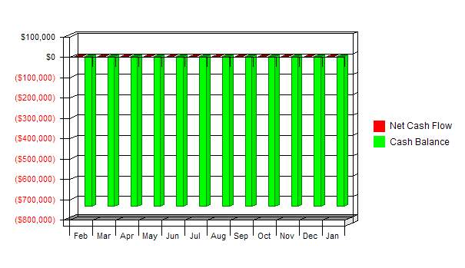

Projected Balance Sheet
To be supplied

Pro Forma Balance Sheet
Assets
Current Assets | FY 2005 | FY 2006 | FY 2007
Cash | ($736,133) | ($735,800) | ($735,347)
Other Current Assets | $0 | $0 | $0
Total Current Assets | ($736,133) | ($735,800) | ($735,347)
Long-term Assets
Long-term Assets | $0 | $0 | $0
Accumulated Depreciation | $0 | $0 | $0
Total Long-term Assets | $0 | $0 | $0
Total Assets | ($736,133) | ($735,800) | ($735,347)
Liabilities and Capital
Current Liabilities | FY 2005 | FY 2006 | FY 2007
Accounts Payable | $22 | $29 | $39
Current Borrowing | $0 | $0 | $0
Other Current Liabilities | $0 | $0 | $0
Subtotal Current Liabilities | $22 | $29 | $39
Long-term Liabilities | $0 | $0 | $0
Total Liabilities | $22 | $29 | $39
Paid-in Capital | $0 | $0 | $0
Retained Earnings | ($736,000) | ($736,155) | ($735,830)
Earnings | ($155) | $326 | $443
Total Capital | ($736,155) | ($735,830) | ($735,386)
Total Liabilities and Capital | ($736,133) | ($735,800) | ($735,347)
Net Worth | ($736,155) | ($735,830) | ($735,386)

Business Ratios
To be supplied

Ratio Analysis
 | FY 2005 | FY 2006 | FY 2007 | Industry Profile
Sales Growth | 0.00% | 31.61% | 32.05% | 0.00%
Percent of Total Assets
Accounts Receivable | 0.00% | 0.00% | 0.00% | 0.00%
Inventory | 0.00% | 0.00% | 0.00% | 0.00%
Other Current Assets | 0.00% | 0.00% | 0.00% | 100.00%
Total Current Assets | 100.00% | 100.00% | 100.00% | 100.00%
Long-term Assets | 0.00% | 0.00% | 0.00% | 0.00%
Total Assets | 100.00% | 100.00% | 100.00% | 100.00%
Current Liabilities | 0.00% | 0.00% | -0.01% | 0.00%
Long-term Liabilities | 0.00% | 0.00% | 0.00% | 0.00%
Total Liabilities | 0.00% | 0.00% | -0.01% | 0.00%
Net Worth | 100.00% | 100.00% | 100.01% | 100.00%
Percent of Sales
Sales | 100.00% | 100.00% | 100.00% | 100.00%
Gross Margin | 80.54% | 83.64% | 86.29% | 0.00%
Selling, General & Administrative Expenses | 112.00% | 33.46% | 34.51% | 0.00%
Advertising Expenses | 0.00% | 0.00% | 0.00% | 0.00%
Profit Before Interest and Taxes | -31.47% | 83.64% | 86.29% | 0.00%
Main Ratios
Current | -32983.10 | -25050.03 | -18957.91 | 0.00
Quick | -32983.91 | -25050.83 | -18958.71 | 0.00
Total Debt to Total Assets | 0.00% | 0.00% | -0.01% | 0.00%
Pre-tax Return on Net Worth | 0.02% | -0.07% | -0.10% | 0.00%
Pre-tax Return on Assets | 0.02% | -0.07% | -0.10% | 0.00%
Additional Ratios | FY 2005 | FY 2006 | FY 2007
Net Profit Margin | -31.47% | 50.19% | 51.77% | n.a
Return on Equity | 0.00% | 0.00% | 0.00% | n.a
Activity Ratios
Accounts Receivable Turnover | 0.00 | 0.00 | 0.00 | n.a
Collection Days | 0 | 0 | 0 | n.a
Inventory Turnover | 0.00 | 0.00 | 0.00 | n.a
Accounts Payable Turnover | 7.52 | 11.00 | 10.65 | n.a
Payment Days | 28 | 42 | 30 | n.a
Total Asset Turnover | 0.00 | 0.00 | 0.00 | n.a
Debt Ratios
Debt to Net Worth | 0.00 | 0.00 | 0.00 | n.a
Current Liab. to Liab. | 1.00 | 1.00 | 1.00 | n.a
Liquidity Ratios
Net Working Capital | ($736,155) | ($735,830) | ($735,386) | n.a
Interest Coverage | 0.00 | 0.00 | 0.00 | n.a
Additional Ratios
Assets to Sales | -1493.67 | -1134.41 | -858.52 | n.a
Current Debt/Total Assets | 0% | 0% | 0% | n.a
Acid Test | -32983.91 | -25050.83 | -18958.71 | n.a
Sales/Net Worth | 0.00 | 0.00 | 0.00 | n.a
Dividend Payout | 0.00 | 0.00 | 0.00 | n.a

Sales Forecast
Sales |  | Feb | Mar | Apr | May | Jun | Jul | Aug | Sep | Oct | Nov | Dec | Jan
Data Suppliers |  | $1 | $1 | $1 | $1 | $2 | $2 | $2 | $2 | $2 | $3 | $3 | $3
CROs |  | $1 | $1 | $1 | $1 | $1 | $1 | $2 | $2 | $2 | $2 | $2 | $2
Appliance Vendor |  | $0 | $0 | $1 | $1 | $1 | $1 | $1 | $1 | $1 | $1 | $1 | $1
Device Vendor |  | $0 | $0 | $1 | $2 | $3 | $3 | $4 | $4 | $5 | $5 | $5 | $6
Imaging Centers |  | $20 | $22 | $24 | $26 | $28 | $31 | $34 | $37 | $40 | $43 | $47 | $52
Total Sales |  | $22 | $24 | $28 | $32 | $35 | $38 | $42 | $45 | $50 | $54 | $58 | $64
Direct Cost of Sales |  | Feb | Mar | Apr | May | Jun | Jul | Aug | Sep | Oct | Nov | Dec | Jan
Software Development |  | $1 | $1 | $1 | $2 | $2 | $3 | $3 | $4 | $5 | $6 | $7 | $9
Marketing |  | $0 | $0 | $0 | $1 | $1 | $1 | $1 | $1 | $2 | $2 | $3 | $3
Systems Integration |  | $2 | $2 | $2 | $2 | $3 | $3 | $3 | $3 | $3 | $4 | $4 | $4
Subtotal Direct Cost of Sales |  | $3 | $4 | $4 | $5 | $6 | $6 | $7 | $9 | $10 | $12 | $14 | $16

Personnel Plan
 |  | Feb | Mar | Apr | May | Jun | Jul | Aug | Sep | Oct | Nov | Dec | Jan
Adrian Gropper |  | $10 | $10 | $10 | $10 | $10 | $10 | $10 | $10 | $10 | $10 | $10 | $10
Sean Doyle |  | $10 | $10 | $10 | $10 | $10 | $10 | $10 | $10 | $10 | $10 | $10 | $10
Bill Donner |  | $10 | $10 | $10 | $10 | $10 | $10 | $10 | $10 | $10 | $10 | $10 | $10
Hugh V. Cottingham |  | $10 | $10 | $10 | $10 | $10 | $10 | $10 | $10 | $10 | $10 | $10 | $10
Total People |  | 0 | 0 | 0 | 0 | 0 | 0 | 0 | 0 | 0 | 0 | 0 | 0
Total Payroll |  | $40 | $40 | $40 | $40 | $40 | $40 | $40 | $40 | $40 | $40 | $40 | $40

General Assumptions
 |  | Feb | Mar | Apr | May | Jun | Jul | Aug | Sep | Oct | Nov | Dec | Jan
Plan Month |  | 1 | 2 | 3 | 4 | 5 | 6 | 7 | 8 | 9 | 10 | 11 | 12
Current Interest Rate |  | 5.00% | 5.00% | 5.00% | 5.00% | 5.00% | 5.00% | 5.00% | 5.00% | 5.00% | 5.00% | 5.00% | 5.00%
Long-term Interest Rate |  | 7.00% | 7.00% | 7.00% | 7.00% | 7.00% | 7.00% | 7.00% | 7.00% | 7.00% | 7.00% | 7.00% | 7.00%
Tax Rate |  | 40.00% | 40.00% | 40.00% | 40.00% | 40.00% | 40.00% | 40.00% | 40.00% | 40.00% | 40.00% | 40.00% | 40.00%
Other |  | 0 | 0 | 0 | 0 | 0 | 0 | 0 | 0 | 0 | 0 | 0 | 0

Pro Forma Profit and Loss
 |  | Feb | Mar | Apr | May | Jun | Jul | Aug | Sep | Oct | Nov | Dec | Jan
Sales |  | $22 | $24 | $28 | $32 | $35 | $38 | $42 | $45 | $50 | $54 | $58 | $64
Direct Costs of Goods |  | $3 | $4 | $4 | $5 | $6 | $6 | $7 | $9 | $10 | $12 | $14 | $16
Other Costs of Goods |  | $0 | $0 | $0 | $0 | $0 | $0 | $0 | $0 | $0 | $0 | $0 | $0
 |  | ------------ | ------------ | ------------ | ------------ | ------------ | ------------ | ------------ | ------------ | ------------ | ------------ | ------------ | ------------
Cost of Goods Sold |  | $3 | $4 | $4 | $5 | $6 | $6 | $7 | $9 | $10 | $12 | $14 | $16
Gross Margin |  | $19 | $20 | $24 | $27 | $30 | $32 | $35 | $37 | $40 | $42 | $45 | $48
Gross Margin % |  | 85.00% | 84.44% | 84.95% | 84.66% | 84.21% | 83.16% | 82.41% | 81.08% | 79.98% | 78.27% | 76.35% | 74.58%
Expenses:
Payroll |  | $40 | $40 | $40 | $40 | $40 | $40 | $40 | $40 | $40 | $40 | $40 | $40
Sales and Marketing and Other Expenses |  | $0 | $0 | $0 | $0 | $0 | $0 | $0 | $0 | $0 | $0 | $0 | $0
Depreciation |  | $0 | $0 | $0 | $0 | $0 | $0 | $0 | $0 | $0 | $0 | $0 | $0
Rent |  | $0 | $0 | $0 | $0 | $0 | $0 | $0 | $0 | $0 | $0 | $0 | $0
Utilities |  | $0 | $0 | $0 | $0 | $0 | $0 | $0 | $0 | $0 | $0 | $0 | $0
Insurance |  | $0 | $0 | $0 | $0 | $0 | $0 | $0 | $0 | $0 | $0 | $0 | $0
Payroll Taxes | 15% | $6 | $6 | $6 | $6 | $6 | $6 | $6 | $6 | $6 | $6 | $6 | $6
Other |  | $0 | $0 | $0 | $0 | $0 | $0 | $0 | $0 | $0 | $0 | $0 | $0
 |  | ------------ | ------------ | ------------ | ------------ | ------------ | ------------ | ------------ | ------------ | ------------ | ------------ | ------------ | ------------
Total Operating Expenses |  | $46 | $46 | $46 | $46 | $46 | $46 | $46 | $46 | $46 | $46 | $46 | $46
Profit Before Interest and Taxes |  | ($27) | ($26) | ($22) | ($19) | ($16) | ($14) | ($11) | ($9) | ($6) | ($4) | ($1) | $2
Interest Expense |  | $0 | $0 | $0 | $0 | $0 | $0 | $0 | $0 | $0 | $0 | $0 | $0
Taxes Incurred |  | $0 | $0 | $0 | $0 | $0 | $0 | $0 | $0 | $0 | $0 | $0 | $0
Net Profit |  | ($27) | ($26) | ($22) | ($19) | ($16) | ($14) | ($11) | ($9) | ($6) | ($4) | ($1) | $2
Net Profit/Sales |  | -124.09% | -107.30% | -78.40% | -61.23% | -46.79% | -38.09% | -27.07% | -20.30% | -11.94% | -6.83% | -2.39% | 2.92%

Pro Forma Cash Flow
 |  | Feb | Mar | Apr | May | Jun | Jul | Aug | Sep | Oct | Nov | Dec | Jan
Cash Received
Cash from Operations:
Cash Sales |  | $22 | $24 | $28 | $32 | $35 | $38 | $42 | $45 | $50 | $54 | $58 | $64
Cash from Receivables |  | $0 | $0 | $0 | $0 | $0 | $0 | $0 | $0 | $0 | $0 | $0 | $0
Subtotal Cash from Operations |  | $22 | $24 | $28 | $32 | $35 | $38 | $42 | $45 | $50 | $54 | $58 | $64
Additional Cash Received
Sales Tax, VAT, HST/GST Received | 0.00% | $0 | $0 | $0 | $0 | $0 | $0 | $0 | $0 | $0 | $0 | $0 | $0
New Current Borrowing |  | $0 | $0 | $0 | $0 | $0 | $0 | $0 | $0 | $0 | $0 | $0 | $0
New Other Liabilities (interest-free) |  | $0 | $0 | $0 | $0 | $0 | $0 | $0 | $0 | $0 | $0 | $0 | $0
New Long-term Liabilities |  | $0 | $0 | $0 | $0 | $0 | $0 | $0 | $0 | $0 | $0 | $0 | $0
Sales of Other Current Assets |  | $0 | $0 | $0 | $0 | $0 | $0 | $0 | $0 | $0 | $0 | $0 | $0
Sales of Long-term Assets |  | $0 | $0 | $0 | $0 | $0 | $0 | $0 | $0 | $0 | $0 | $0 | $0
New Investment Received |  | $0 | $0 | $0 | $0 | $0 | $0 | $0 | $0 | $0 | $0 | $0 | $0
Subtotal Cash Received |  | $22 | $24 | $28 | $32 | $35 | $38 | $42 | $45 | $50 | $54 | $58 | $64
Expenditures |  | Feb | Mar | Apr | May | Jun | Jul | Aug | Sep | Oct | Nov | Dec | Jan
Expenditures from Operations:
Cash Spending |  | $40 | $40 | $40 | $40 | $40 | $40 | $40 | $40 | $40 | $40 | $40 | $40
Payment of Accounts Payable |  | $0 | $9 | $10 | $10 | $11 | $12 | $12 | $13 | $15 | $16 | $18 | $20
Subtotal Spent on Operations |  | $40 | $49 | $50 | $50 | $51 | $52 | $52 | $53 | $55 | $56 | $58 | $60
Additional Cash Spent
Sales Tax, VAT, HST/GST Paid Out |  | $0 | $0 | $0 | $0 | $0 | $0 | $0 | $0 | $0 | $0 | $0 | $0
Principal Repayment of Current Borrowing |  | $0 | $0 | $0 | $0 | $0 | $0 | $0 | $0 | $0 | $0 | $0 | $0
Other Liabilities Principal Repayment |  | $0 | $0 | $0 | $0 | $0 | $0 | $0 | $0 | $0 | $0 | $0 | $0
Long-term Liabilities Principal Repayment |  | $0 | $0 | $0 | $0 | $0 | $0 | $0 | $0 | $0 | $0 | $0 | $0
Purchase Other Current Assets |  | $0 | $0 | $0 | $0 | $0 | $0 | $0 | $0 | $0 | $0 | $0 | $0
Purchase Long-term Assets |  | $0 | $0 | $0 | $0 | $0 | $0 | $0 | $0 | $0 | $0 | $0 | $0
Dividends |  | $0 | $0 | $0 | $0 | $0 | $0 | $0 | $0 | $0 | $0 | $0 | $0
Subtotal Cash Spent |  | $40 | $49 | $50 | $50 | $51 | $52 | $52 | $53 | $55 | $56 | $58 | $60
Net Cash Flow |  | ($18) | ($25) | ($22) | ($19) | ($16) | ($14) | ($10) | ($8) | ($5) | ($2) | $1 | $4
Cash Balance |  | ($736,018) | ($736,043) | ($736,065) | ($736,084) | ($736,099) | ($736,113) | ($736,123) | ($736,131) | ($736,136) | ($736,138) | ($736,137) | ($736,133)

Pro Forma Balance Sheet
Assets
Current Assets | Starting Balances | Feb | Mar | Apr | May | Jun | Jul | Aug | Sep | Oct | Nov | Dec | Jan
Cash | ($736,000) | ($736,018) | ($736,043) | ($736,065) | ($736,084) | ($736,099) | ($736,113) | ($736,123) | ($736,131) | ($736,136) | ($736,138) | ($736,137) | ($736,133)
Other Current Assets | $0 | $0 | $0 | $0 | $0 | $0 | $0 | $0 | $0 | $0 | $0 | $0 | $0
Total Current Assets | ($736,000) | ($736,018) | ($736,043) | ($736,065) | ($736,084) | ($736,099) | ($736,113) | ($736,123) | ($736,131) | ($736,136) | ($736,138) | ($736,137) | ($736,133)
Long-term Assets
Long-term Assets | $0 | $0 | $0 | $0 | $0 | $0 | $0 | $0 | $0 | $0 | $0 | $0 | $0
Accumulated Depreciation | $0 | $0 | $0 | $0 | $0 | $0 | $0 | $0 | $0 | $0 | $0 | $0 | $0
Total Long-term Assets | $0 | $0 | $0 | $0 | $0 | $0 | $0 | $0 | $0 | $0 | $0 | $0 | $0
Total Assets | ($736,000) | ($736,018) | ($736,043) | ($736,065) | ($736,084) | ($736,099) | ($736,113) | ($736,123) | ($736,131) | ($736,136) | ($736,138) | ($736,137) | ($736,133)
Liabilities and Capital
Current Liabilities |  | Feb | Mar | Apr | May | Jun | Jul | Aug | Sep | Oct | Nov | Dec | Jan
Accounts Payable | $0 | $9 | $10 | $10 | $11 | $12 | $12 | $13 | $15 | $16 | $18 | $20 | $22
Current Borrowing | $0 | $0 | $0 | $0 | $0 | $0 | $0 | $0 | $0 | $0 | $0 | $0 | $0
Other Current Liabilities | $0 | $0 | $0 | $0 | $0 | $0 | $0 | $0 | $0 | $0 | $0 | $0 | $0
Subtotal Current Liabilities | $0 | $9 | $10 | $10 | $11 | $12 | $12 | $13 | $15 | $16 | $18 | $20 | $22
Long-term Liabilities | $0 | $0 | $0 | $0 | $0 | $0 | $0 | $0 | $0 | $0 | $0 | $0 | $0
Total Liabilities | $0 | $9 | $10 | $10 | $11 | $12 | $12 | $13 | $15 | $16 | $18 | $20 | $22
Paid-in Capital | $0 | $0 | $0 | $0 | $0 | $0 | $0 | $0 | $0 | $0 | $0 | $0 | $0
Retained Earnings | ($736,000) | ($736,000) | ($736,000) | ($736,000) | ($736,000) | ($736,000) | ($736,000) | ($736,000) | ($736,000) | ($736,000) | ($736,000) | ($736,000) | ($736,000)
Earnings | $0 | ($27) | ($53) | ($75) | ($94) | ($111) | ($125) | ($137) | ($146) | ($152) | ($156) | ($157) | ($155)
Total Capital | ($736,000) | ($736,027) | ($736,053) | ($736,075) | ($736,094) | ($736,111) | ($736,125) | ($736,137) | ($736,146) | ($736,152) | ($736,156) | ($736,157) | ($736,155)
Total Liabilities and Capital | ($736,000) | ($736,018) | ($736,043) | ($736,065) | ($736,084) | ($736,099) | ($736,113) | ($736,123) | ($736,131) | ($736,136) | ($736,138) | ($736,137) | ($736,133)
Net Worth | ($736,000) | ($736,027) | ($736,053) | ($736,075) | ($736,094) | ($736,111) | ($736,125) | ($736,137) | ($736,146) | ($736,152) | ($736,156) | ($736,157) | ($736,155)

